Homework M5: Security Integration
Main goal is to build further on what was demonstrated during the practice
Prerequisites may vary between different tasks. You should adjust your infrastructure according to the task you chose to implement

Tasks
Explore Trivy further and why not Grype by choosing to implement one or more of the following
- Create a Gitea Actions workflow or Jenkins pipeline that executes periodically, for example, every day at 20:00 and using Trivy, scans the latest tag of the container images of our four microservices. The workflow/pipeline should also allow manual execution
- Create a Gitea Actions workflow or Jenkins pipeline that executes periodically, for example, every day at 20:00 and using Grype, scans the latest tag of the container images of our four microservices. The workflow/pipeline should also allow manual execution
* The focus should be on achieving the required and not on doing it in the most automated way possible
** Please note that even if you choose to implement more than one task, they may be quite independent and different. So, you may need to create a separate infrastructure (environment) for each or at least clean it every time

Proof
Prepare a document that shows what you accomplished and how you did it. It can include (not limited to):
- The commands you used to achieve the above tasks
- A few pictures showing intermediary steps or results

I Playing with Trivy
1. Installing Trivy and checking that is working
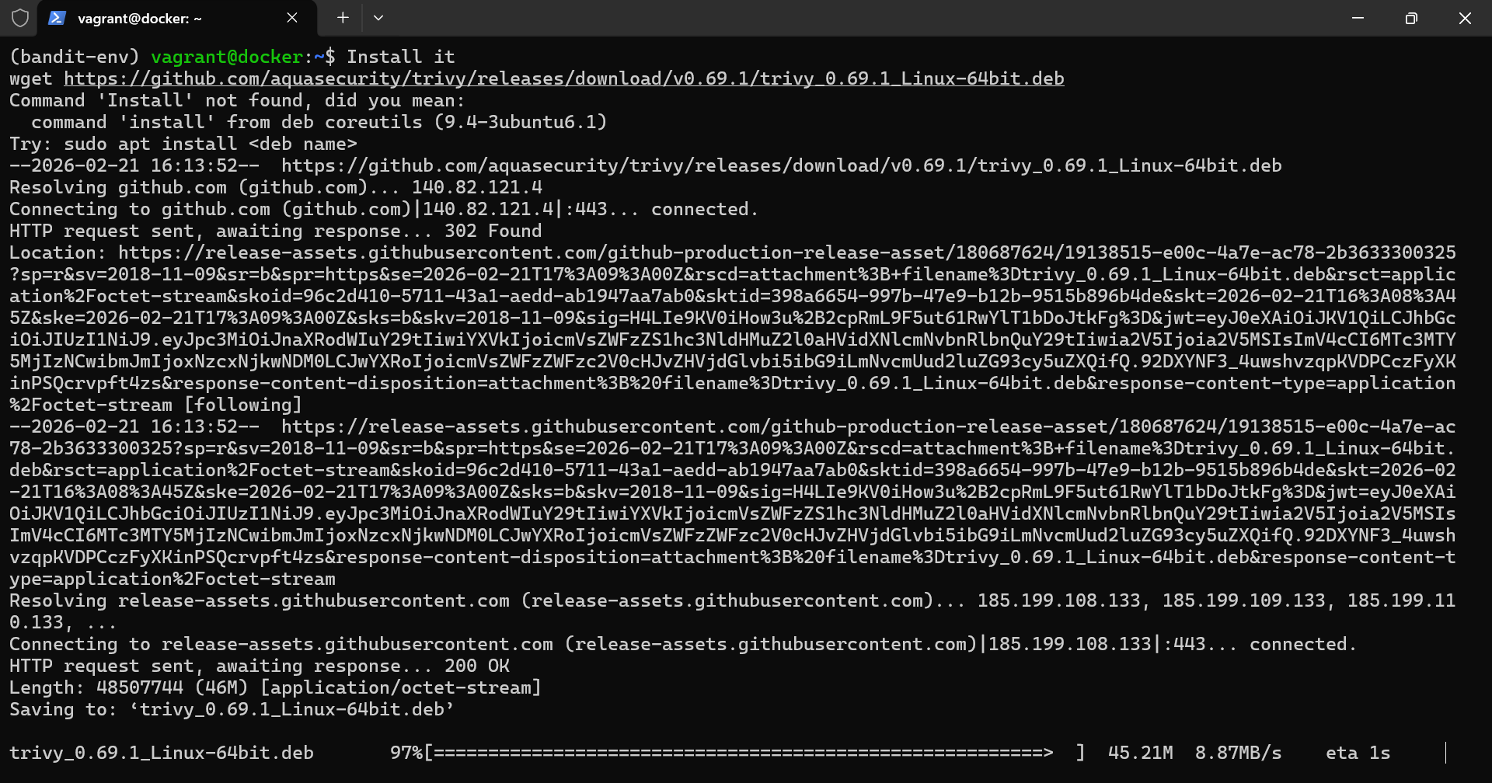
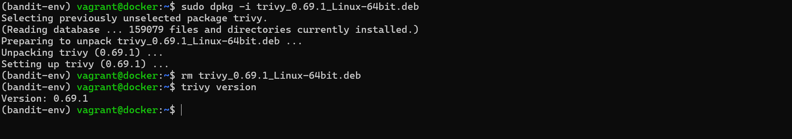
2. Adding keys to the repositories
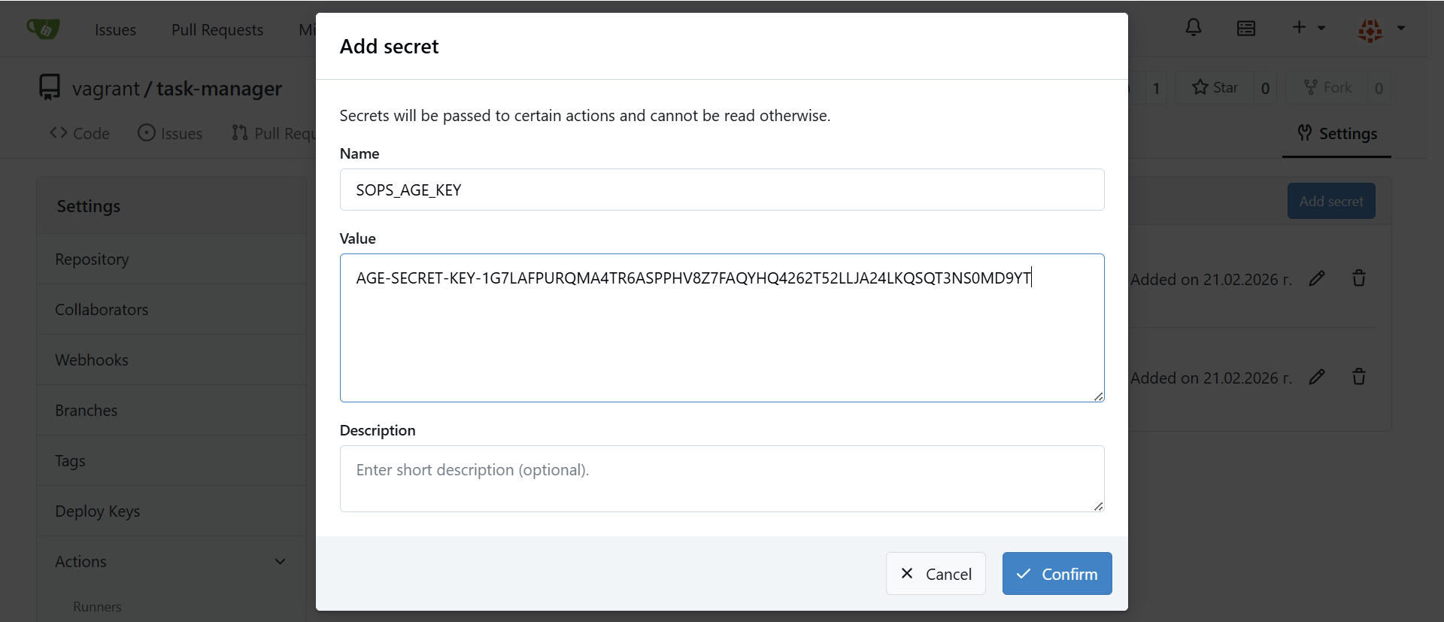
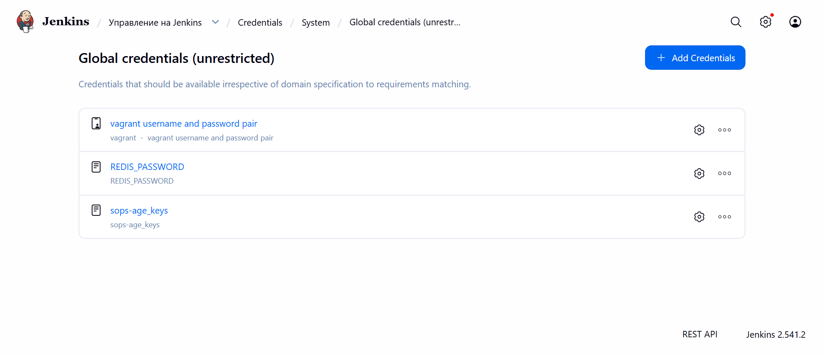
3. Adding the trivy to the gitea pipeline
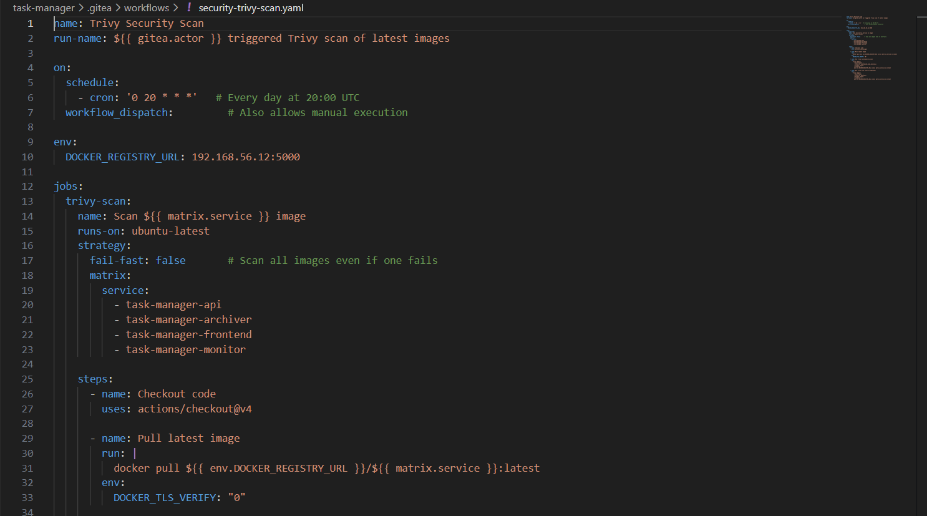
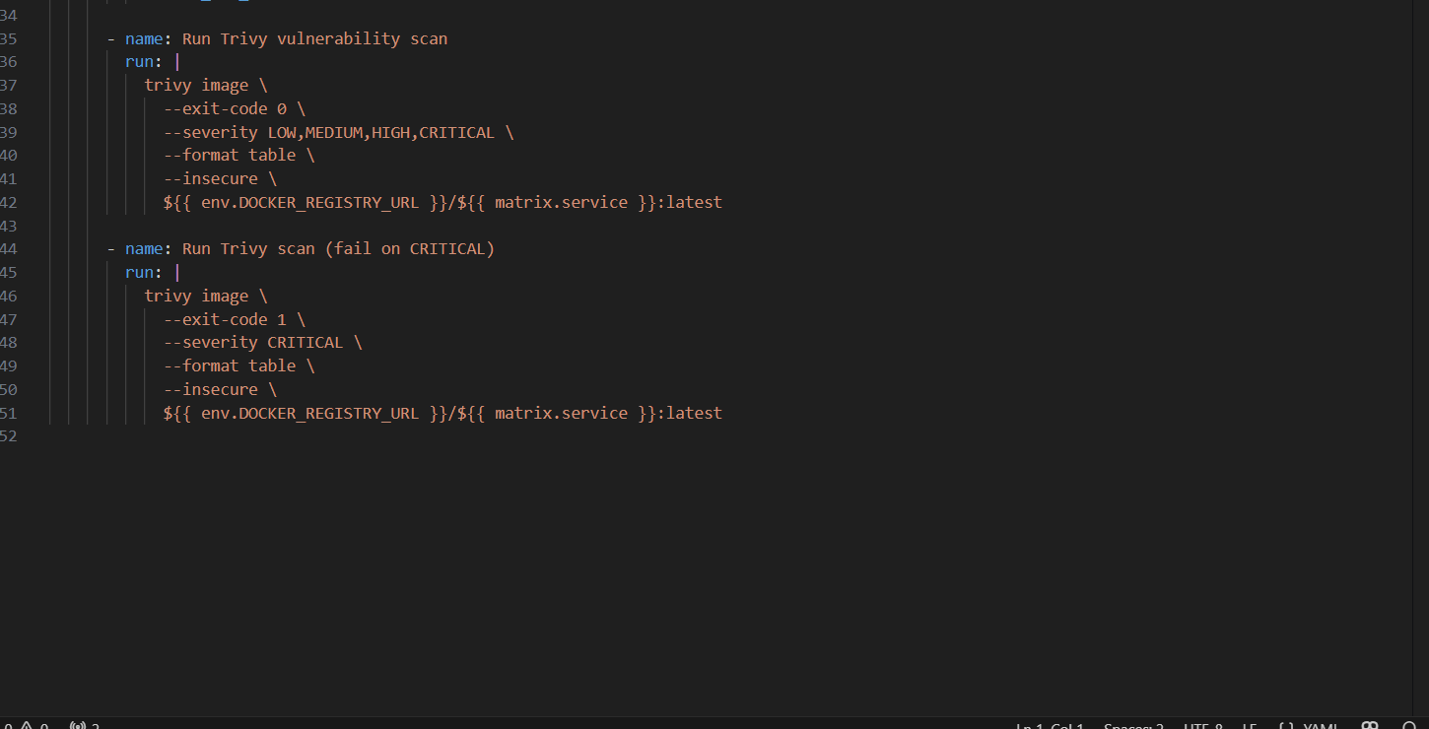
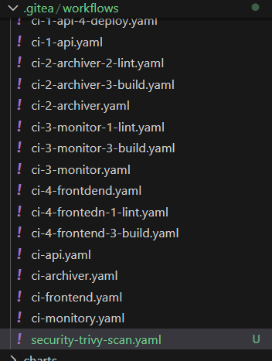
4. Adding trivy to the Jenkins pipeline
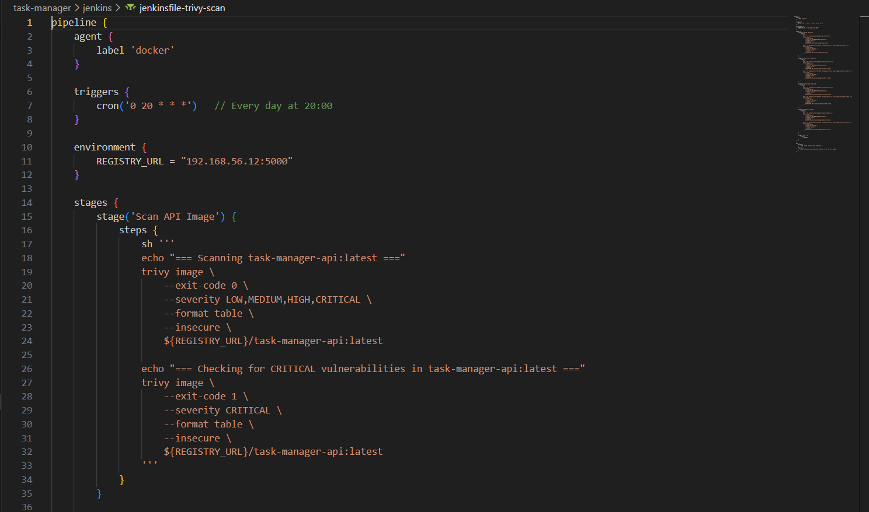
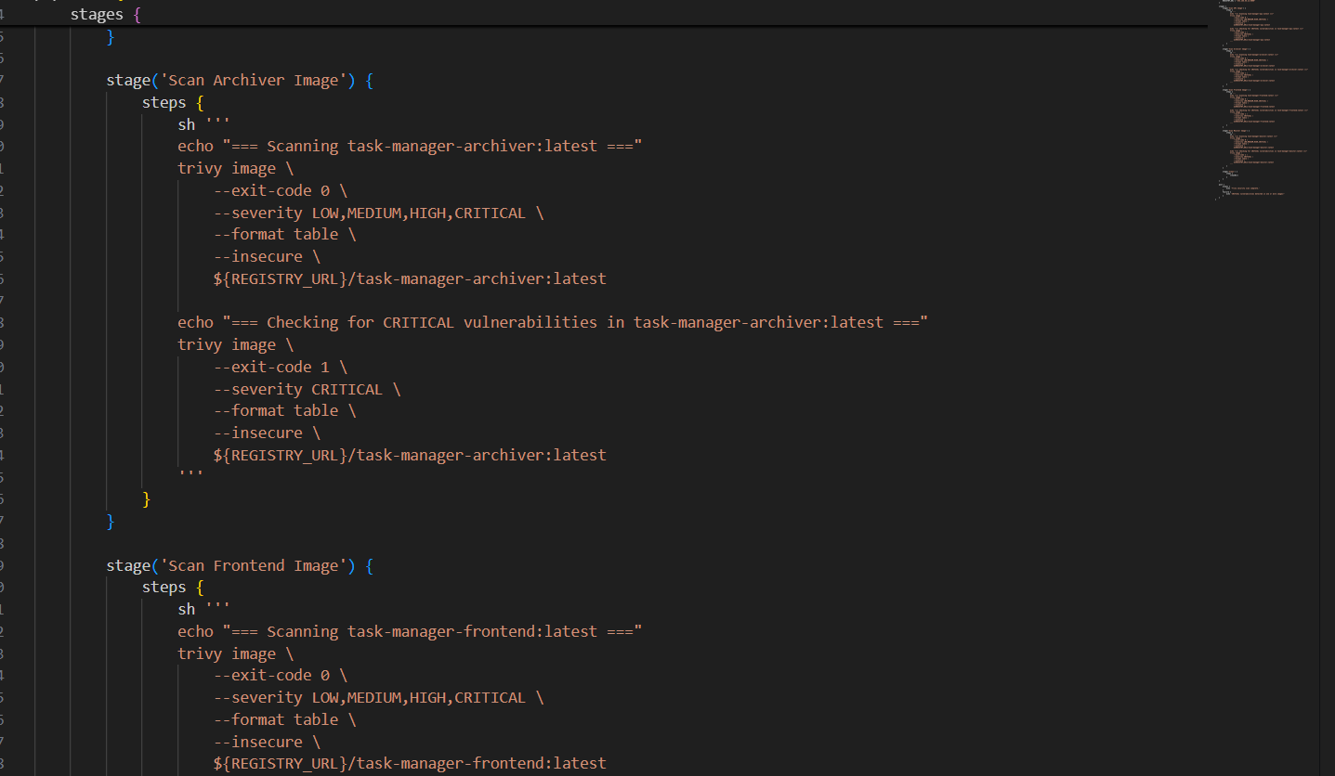
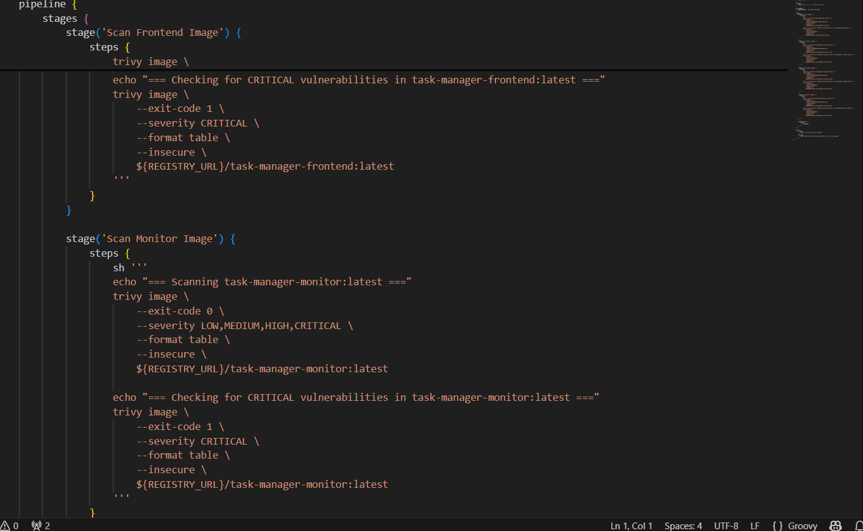
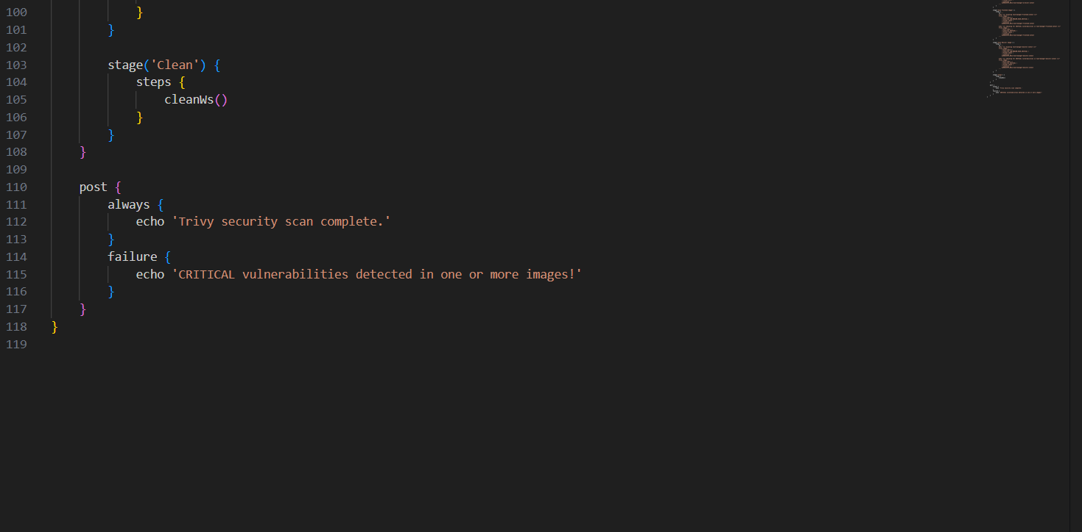
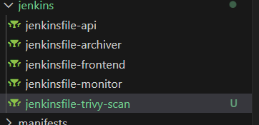
5. adding the newly created files to the gitea repository
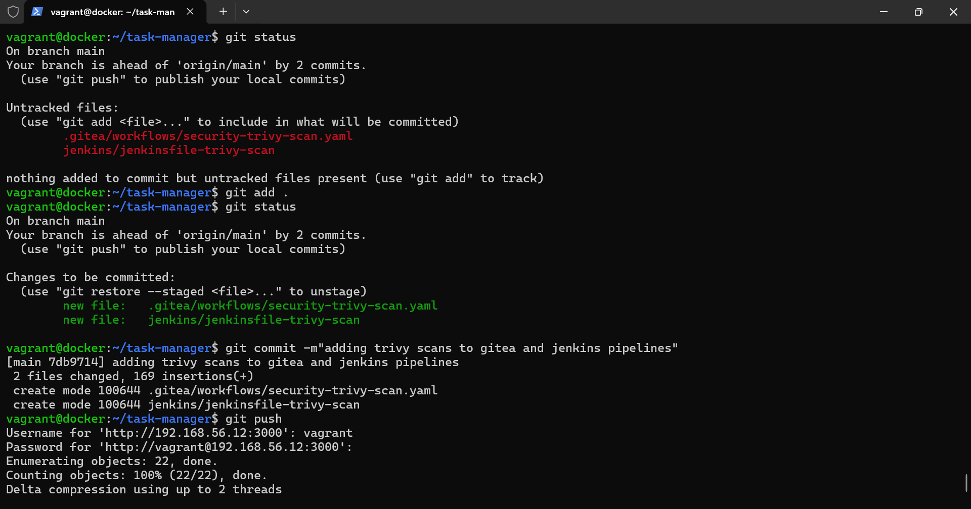

II Playing with Grype
1.Installing Grype and check if its working
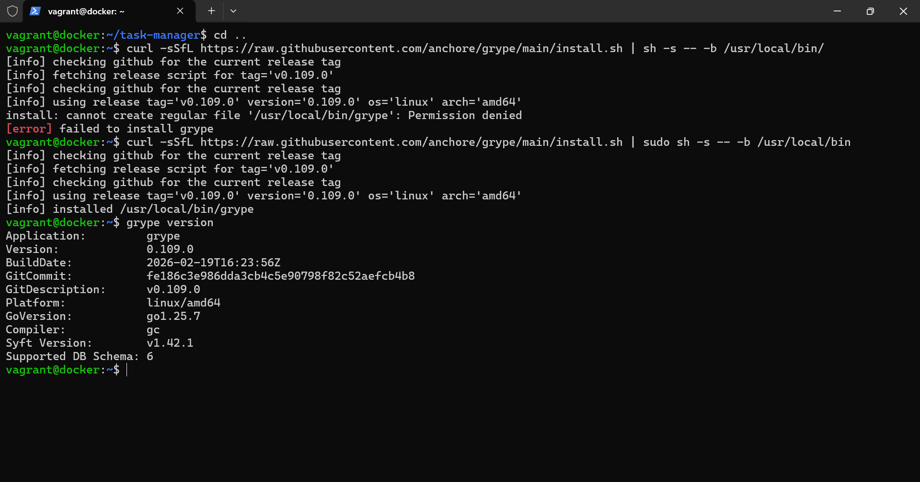
2.Creating gitea action security-grype scan
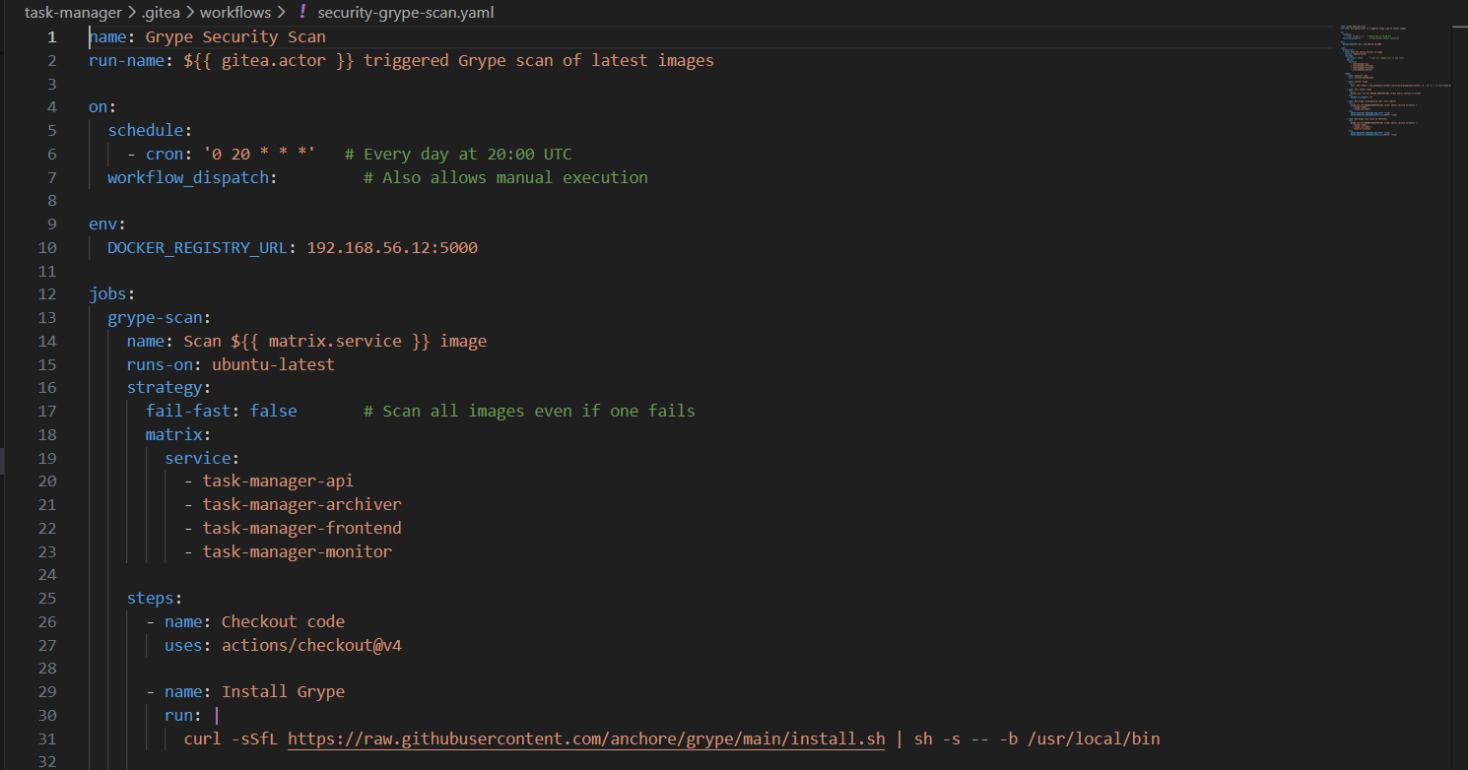
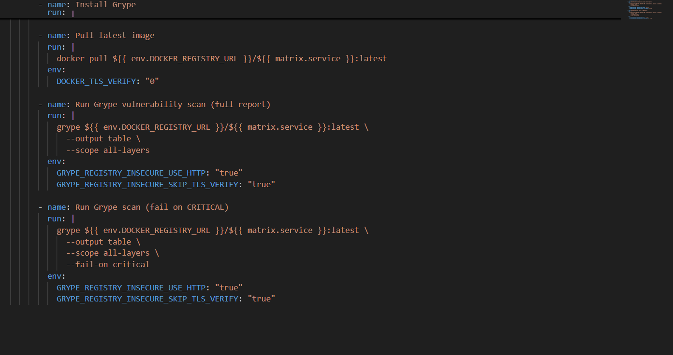
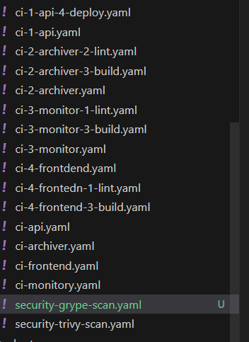
3. Creating Jenkins grype scan file
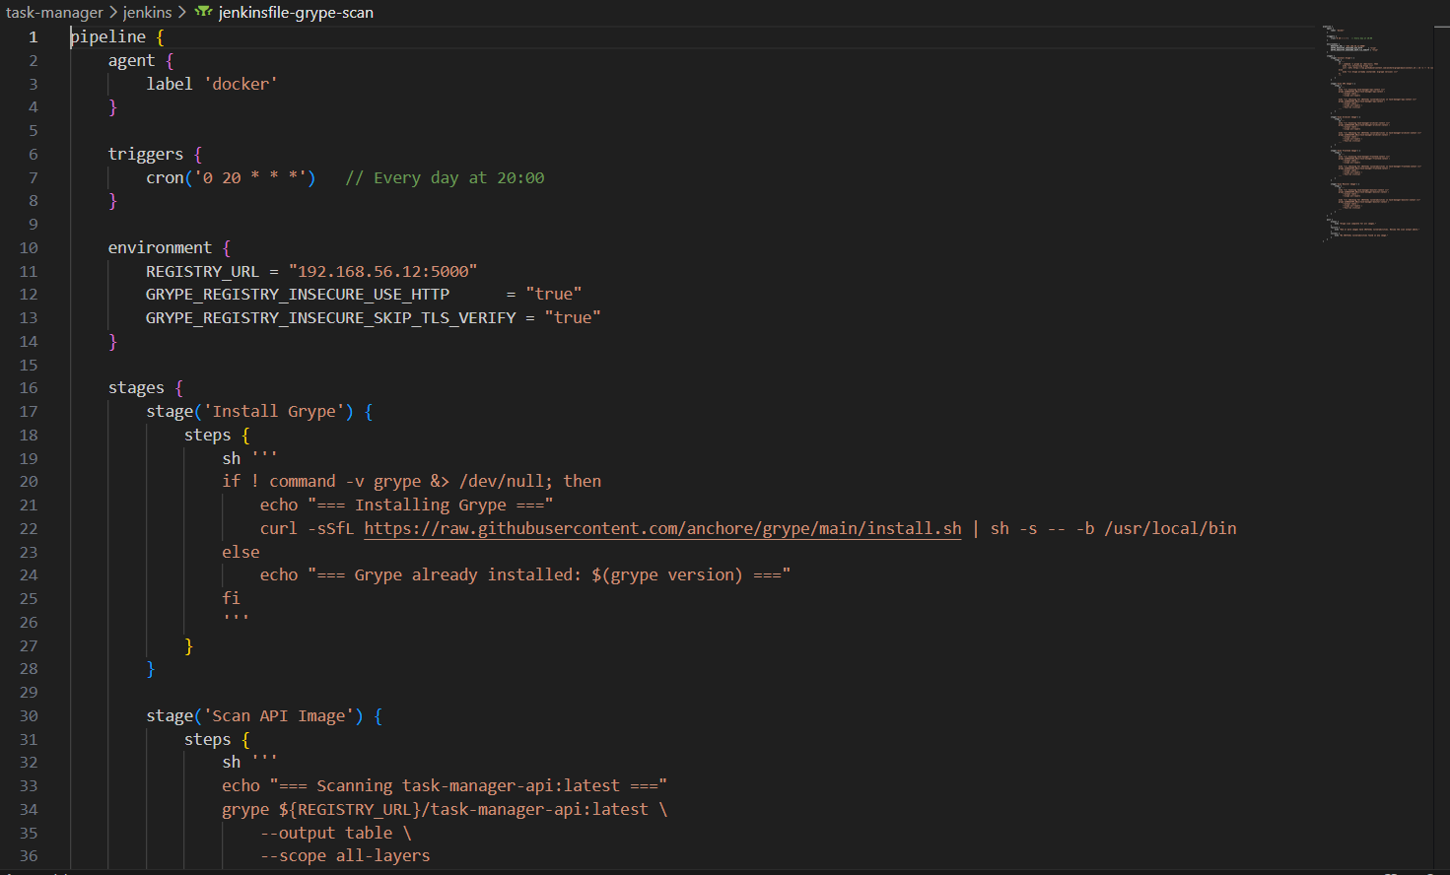
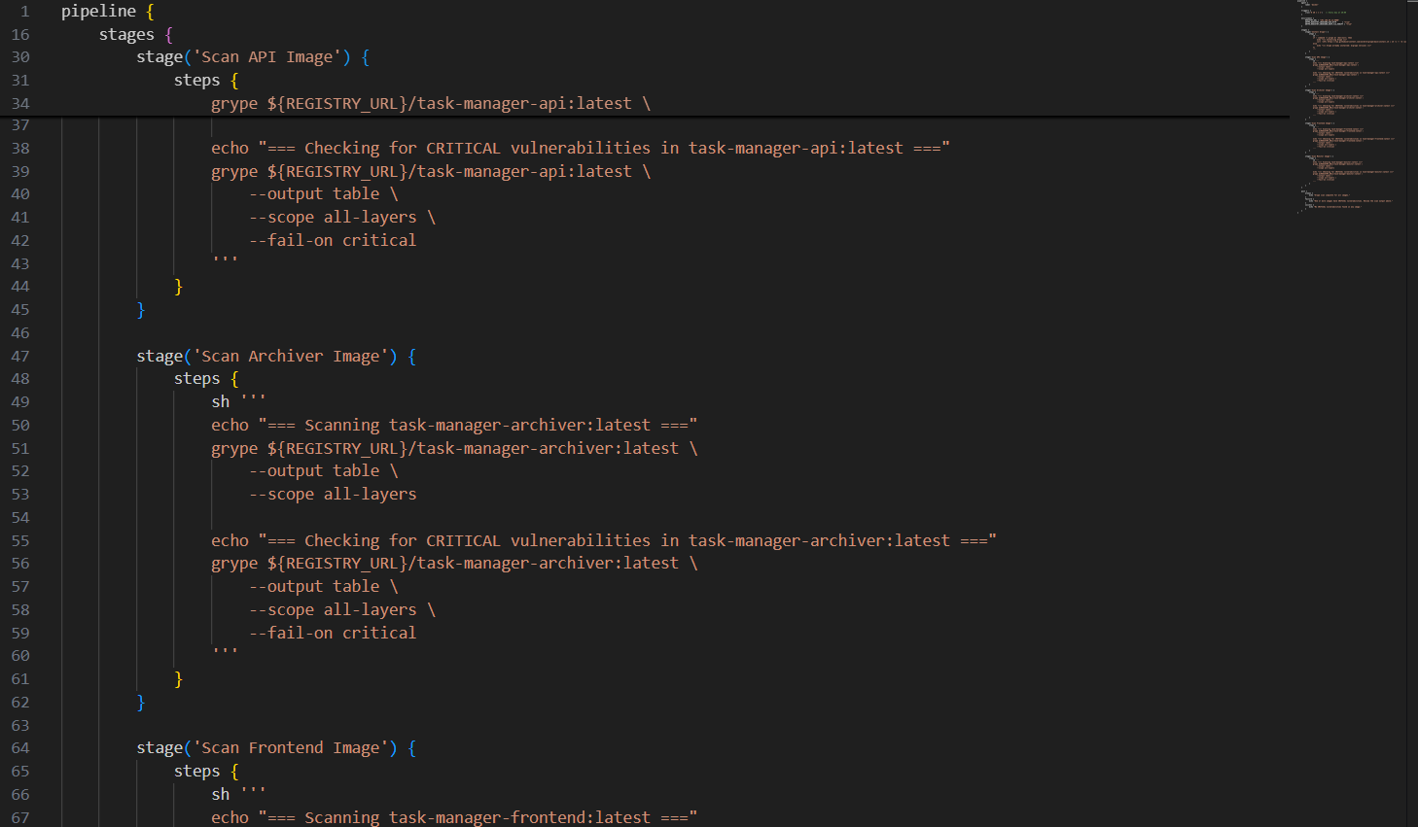
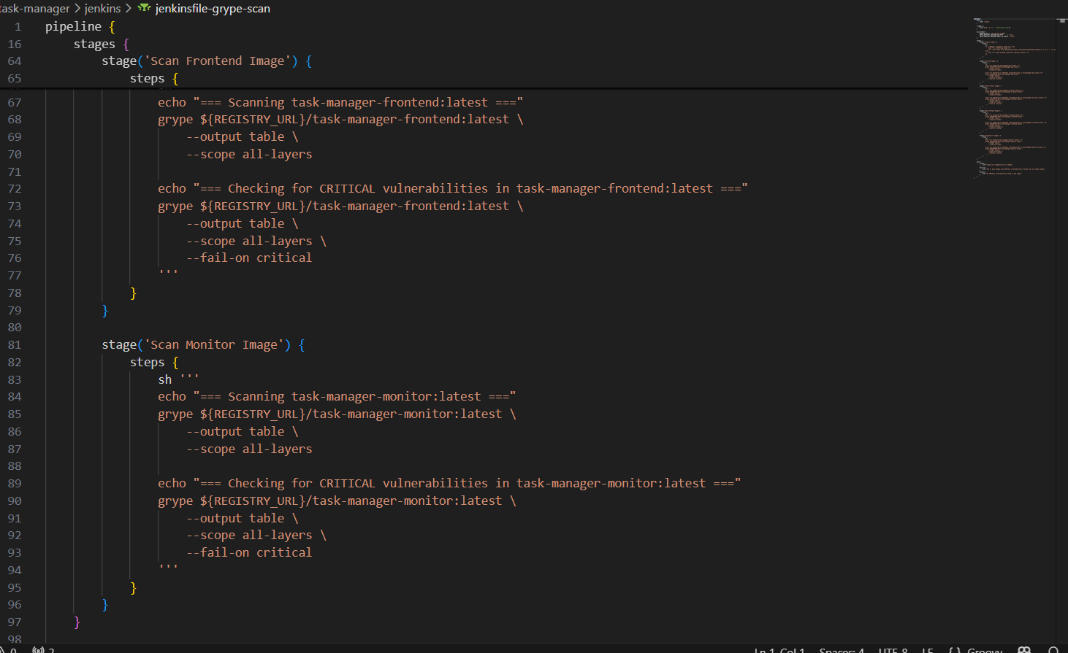
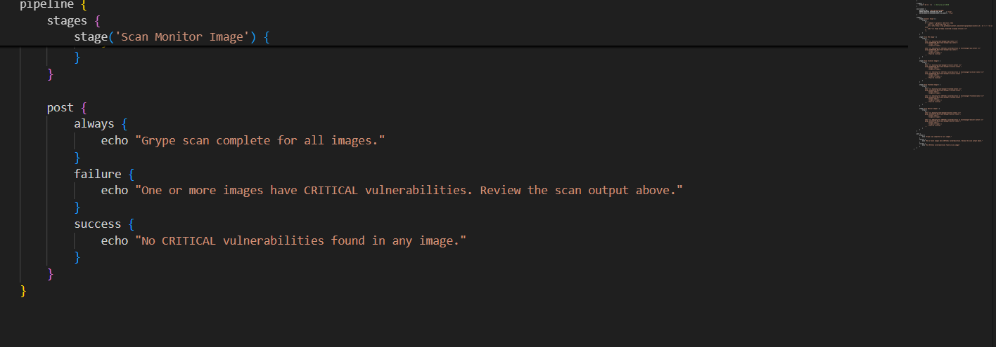
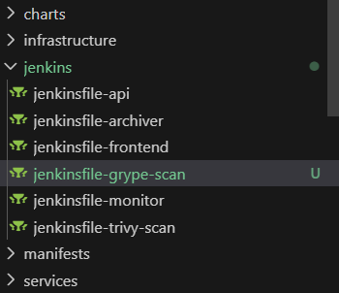
4. Adding to the repository
